 | Магістерська  Франко-українська програма  подвійного диплому  MBA «Бізнес-інформатика» | 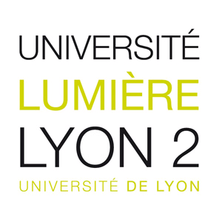
APPLICATION FORM

1. Personal information

Family Name
First (given) Name
Marital status
Date of Birth (day/month/year)
Place of Birth
Citizenship
Прізвище
Ім’я По батькові
Do you have passport for traveling abroad? Yes No
Residence country City
Home telephone: ________________________ Mobile telephone:
Home e-mail

2. Academic background
Undergraduate education (first diploma – бакалавр)
University/Institution:
Country and city:
Faculty (school, department)
Year of admission Year of graduation (expected):
Major field of study:
Degree awarded (bachelor, specialist, etc.):
Diploma No.: ____________________________________ With distinction? Yes No
Average point (середній бал):
Other obtained education (if applicable, in chronological order)
№ | Name of University/Institution and its location | Faculty (school/ department) | Major | Dates of admission and graduation (anticipated) | Awarded degree
1 | niversité Lumière Lyon 2 (France, Lyon) ; Erasmus+

3. Professional experience and internships (if applicable)
№ | Name of company and dates of  employment / internship | Nature of work and position held | Duties
1
2
3

List any conferences, trainings, competitions and other professional events you took part in:
Year | Event | Organizer | Degree or certificate

Do you want to add something about your educational level and background?

4. Languages
Describe your language skills (please use the proficiency scale provided)
Scale: A. Fluent; B. Advanced Skills; C. Intermediate Skills; D. Introductory/Basic Skills
Language | Speaking | Reading | Writing

5. Your motivation

Name
Date

